Unite-2 Using UML

2.1 Object model notation.
These notes show how the Unified Modeling Language (UML) can be used to document and design simple classes. For that use the some useful notation of the object model.
In the UML a class of similar objects is drawn as a rectangular box. It can just contain the name of the class. It can also have two parts: the top part for the name and the second part for the attributes of the objects. It can have three parts: the name, the attributes, and the operations.
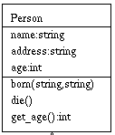
The diagram above tells us a great deal about the calss called Person:
A Person has three attributes: name, address, and age.
A Person's name and address is a string.
A Person's age is an int.
Certain things can happen to a Person. So we have these operations or functions:
born - which needs two string arguments
die - which needs no arguments
age - which returns an int and needs no arguments

Special Relationships between Classes
We can use diagrams to talk about existing code and we can also use them to work out new code. There are some special relationships that hold between classes of objects in a piece of code.

Dependency
It is often useful to know that one class make use of another class in some way or other. This is shown as a dotted arrow from the client class to the class that provides the service.

Composition
UML provides several notations that can express the physical construction of a class. The filled in diamond is often used when a class contain other objects within them as parts or components. Here are two examples:

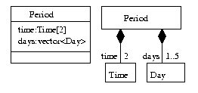

Aggregation
In older UMLs we used an aggregation to indicate a loose form of has:
<>-----
Here is an example showing that a Restaurant will have a number of clients who are People and the the clients exist whether or not they are clients of the Restaurant:
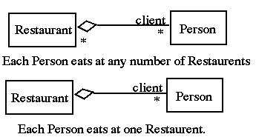

Associations
Associations are a powerful, simple, and useful connection between classes:
-----> One class knows about another
------ Each class knows about the other.
Generalization

This means that the new Derived class extends the property of the old Base class. Each object of Derived can do anything that an object of Base can. Each Derived object holds all the data that a Base object does. Derived classes can redefine and extended the data and operations of the Base class.
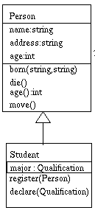

2.2 Basic Concept.
Any complex system is best understood by making some kind of diagrams or pictures. These diagrams have a better impact on our understanding. So if we look around then we will realize that the diagrams are not a new concept but it is used widely in different form in different industries. We prepare UML diagrams to understand a system in better and simple way. A single diagram is not enough to cover all aspects of the system. So UML defines various kinds of diagrams to cover most of the aspects of a system.
What is UML?
UML stands for Unified modeling language. It is a graphical language for visualizing, specifying, constructing and documenting the article of a software intensive system. UML provides blue prints for business process, system function, programming language statements, database schemas and reusable components. The different type of UML diagram is used in the UML is given bellow.
- Use Case Diagram
- Class Diagram
- Activity Diagram
- Sequence Diagram
- Object Diagram
- State Diagram
- Collaboration Diagram
- Deployment Diagram
- Component Diagram
This chapter introduces the fundamental concepts required for effective use of UML Included are descriptions of models, views and diagrams, projects, units, approaches, frameworks, model fragments and their differences as well as UML profile.
- Model, View and Diagram
- Project and Unit
- Module
Model, View and Diagram
StarUML makes a clear conceptual distinction between models, views and diagrams. A Model is an element that contains information for a software model. A View is a visual expression of the information contained in a model, and a Diagram is a collection of view elements that represent the user’s specific design thoughts.
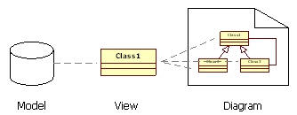

Project and Unit
Project files are saved in the XML format with the extension name “.UML”. All models, views and diagrams created in StarUML are saved in one project file. A project may also be divided up and saved in multiple units. A project file contains the following information.
- UML profiles used in the project
- Unit files referenced by the project
- Information for all models contained in the project
- Information for all diagrams and views contained in the project

Units
While a project is generally saved in one file, there are cases where one project needs to be saved in many smaller files so that a number of developers can work on the project together. In this case, the project can be managed as multiple units. A unit can have a hierarchical structure; it may contain many sub-units under it. Units are saved as .UML files and are referenced by project files (.UML) or other unit files (.UNT).
Module
The module is a package to provide new functions and features as extending StarUML. The module can be created as combinations of several extension elements. Also, you can not only configure only extension element to an independent module for purpose, but also create same typed extension elements in a module.
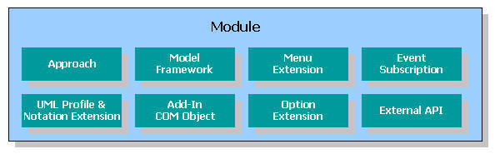
Module of StarUML provides the following functions.
- Expansion of the main menu or popup menu.
- Addition of new approach
- Addition of new profile
- Addition of new profile
- Addition of new element through stereotype or expansion of notation
- Implementation of new function (through COM Server or simple script file)
- Integration with other applications
- Other Add-In functions

2.3 Structural Diagram.
The structural diagrams represent the static aspect of the system. These static aspects represent those parts of a diagram which forms the main structure and therefore it is stable. These static parts are presents by classes, interfaces, objects, components and nodes.

- Structural diagrams are the most important and widely used part of UML. Structural diagrams are class diagrams and object diagrams
  - Class diagrams represent the object-oriented code in your system. They define all possible runs of the program.
  - Object diagrams give specific examples of one possible run of the program with specific data.
- Class diagrams can be used in requirements to express your understanding of the real-world problem and to define the meaning of words you use in your proposed solution.
- In design, class diagrams often have more detail and use more aspects of the UML notation.
- Structure diagrams include following diagrams is given bellow.
- Class diagram
- Object diagram
- Composite Structure diagram
- Component diagram
- Deployment diagram
Different notation is used when creating diagram is given bellow.

Notation
 |  | Aggregation (Shared association) |  |  | Association (Without aggregation)
 |  | Class |  |  | Collaboration
 |  | Collaboration Use |  |  | Connector
 |  | Composition (Composite association) |  |  | Constraint
 |  | Dependency |  |  | Generalization
 |  | Interface |  |  | Note
 |  | Occurrence |  |  | Part
 |  | Port |  |  | Property
 |  | Realization |  |  | Represents

Aggregation (Shared association)
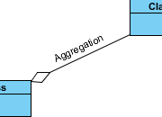 |  | It is also known as “Has A” relationship. Aggregation is a strong form is association in which an aggregate object it is made of constitutes part.
  Definition
  A kind of association that has one of its end marked shared as kind of aggregation, meaning that it has a shared aggregation.

Association (Without aggregation)

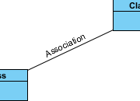
  Definition
  An association specifies a semantic relationship that can occur between typed instances. It has at least two ends represented by properties, each of which is connected to the type of the end. More than one end of the association may have the same type.
  An end property of an association that is owned by an end class or that is a navigable owned end of the association indicates that the association is navigable from the opposite ends; otherwise, the association is not navigable from the opposite ends.

Class
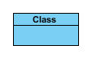
  Definition
  A class describes a set of objects that share the same specifications of features, constraints, and semantics. Class is a kind of classifier whose features are attributes and operations. Attributes of a class are represented by instances of Property that are owned by the class. Some of these attributes may represent the navigable ends of binary associations.

Composition (Composite association)
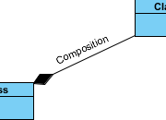
  Definition
  An association may represent a composite aggregation (i.e., a whole/part relationship). Only binary associations can be aggregations. Composite aggregation is a strong form of aggregation that requires a part instance be included in at most one composite at a time. If a composite is deleted, all of its parts are normally deleted with it. Note that a part can (where allowed) be removed from a composite before the composite is deleted, and thus not be deleted as part of the composite.

Dependency
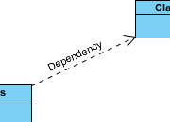
  Definition
  A dependency is a relationship that signifies that a single or a set of model elements requires other model elements for their specification or implementation. This means that the complete semantics of the depending elements is either semantically or structurally dependent on the definition of the supplier element(s).

Generalization
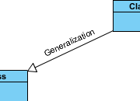
  Definition
  A generalization is a relationship between a more general classifier and a more specific classifier. Each instance of the specific classifier is also an indirect instance of the general classifier. Thus, the specific classifier inherits the features of the more general classifier.
  It is also known as “IS A” relationship because the child class is a type of the parent class.

- Class diagram
- Class diagrams are the most common diagrams used in UML. Class diagram consists of classes, interfaces, association and collaboration.
- Class diagram provide a graphical notation for modeling and their relationship. Class diagram are useful for both abstract and for designing actual program.
- Class diagram are consist easy to understand and work well in practice. Generally the primary step is class diagram; the best way to identify classes is to consider all nouns in use case and verb as method of class.
- Class diagram is a static structure diagram which describes structure of a system at the level of classifiers (classes, interfaces, etc.). It shows some classifiers of the system, subsystem or component, different relationships between classifiers, their attributes and operations, constraints.
- Class diagrams basically represent the object oriented view of a system which is static in nature.
- Class diagram represents the object orientation of a system. So it is generally used for development purpose. This is the most widely used diagram at the time of system construction. The Structure of Class diagram is given bellow.
Class Name
(property) List of Attribute (-) Private
(method) List of function (+) public
Example
Students
- std_id
-std_name
+ search()
+ mark()

Different element of class diagram
- Association
- Multiplication
- Direct association
- Aggregation relationship
- Inheritance/ generalization

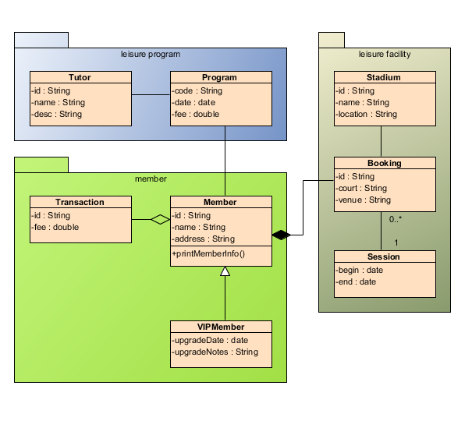
- Object diagram
- Object diagrams can be described as an instance of class diagram. So these diagrams are more close to real life scenarios where we implement a system.
- Object diagrams are a set of objects and their relationships just like class diagrams and also represent the static view of the system.
- The usage of object diagram is similar to class diagrams but they are used to build prototype/example of a system form practical perspective/view.
- Object diagrams are derived from class diagrams so object diagrams are dependent upon class diagrams.
- Object diagram shows a snapshot of instances of things in class diagrams. Similar to class diagrams, object diagrams show the static design of system but from the real or prototype perspective.
- "a graph of instances, including objects and data values. A static object diagram is an instance of a class diagram; it shows a snapshot of the detailed state of a system at a point in time." It also stated that object diagram is "a class diagram with objects and no classes."

Purpose:
The purpose of a diagram should be understood clearly to implement it practically. The purposes of object diagrams are similar to class diagrams.
The difference is that a class diagram represents an abstract model consisting of classes and their relationships. But an object diagram represents an instance at a particular moment which is concrete in nature.

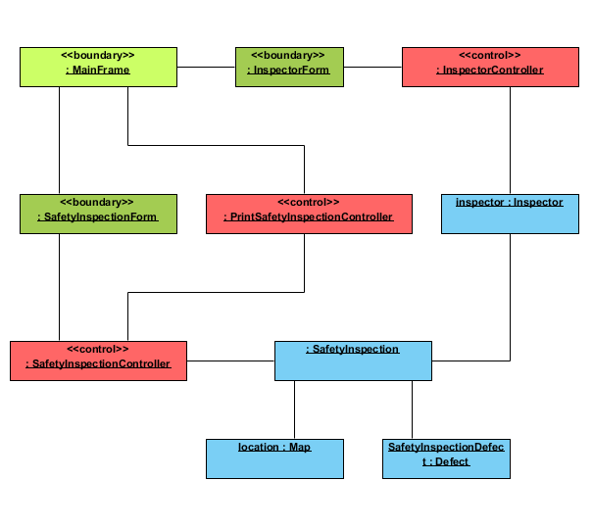

- Composite Structure diagram
- Composite Structure Diagram is one of the new artifacts added to UML 2.0. It shows the internal structure (including parts and connectors) of a structured classifier or collaboration. VP-UML provides full support to the Composite Structure Diagram, includes modeling the internal structure of the objects and functionality.
- Composite structure diagram visualizes the internal structure of a class or collaboration. Composite structure diagram is a kind of component diagram mainly used in modeling a system at micro point-of-view.
- A composite structure diagram is a diagram that shows the internal structure of a classifier, including its interaction points to other parts of the system. It shows the configuration and relationship of parts that together, perform the behavior of the containing classifier.
- Class elements have been described in great detail in the section on class diagrams. This section describes the way classes can be displayed as composite elements exposing interfaces and containing ports and parts.
- Composite structure diagram supports the ball and socket notation for the provided and required interface. Interfaces can be shown or hidden in the diagram as needed.
- Composite structure diagram is similar to a class diagram but it depicts individual parts instead of whole classes.
- In composite structure diagrams, ports define the interaction point between a classifier and its environment or between a classifier and its internal parts.
Part
part is an element that represents a set of one or more instances which are owned by a containing classifier instance. A part describes the role of an instance in a classifiere.
Port
port is a typed element that represents an externally visible part of a containing classifier instance. Ports define the interaction between a classifier and its environment.

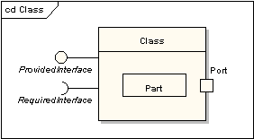

OR
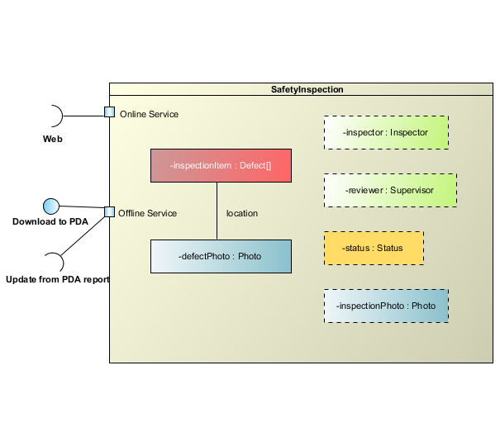
- Component diagram
- Component diagram represent a set of components and their relationships. These components consist of classes and interfaces. So component diagrams represent the implementation view of a system.
- During design phase software artifacts (classes, interfaces etc) of a system are arranged in different groups depending upon their relationship. Now this group are known as components.
- Component diagram shows components and dependencies between them. This type of diagrams is used for Component-Based Development (CBD), to describe systems with Service-Oriented Architecture (SOA).
- The Component Diagram helps to model the physical aspect of an Object-Oriented software system. It illustrates the architectures of the software components and the dependencies between them. Those software components including run-time components, executable components also the source code components.
- A component is a structured class representing a modular part of a system with encapsulated content and whose manifestation/expression is replaceable within its environment.
- Finally component diagrams are used to visualize the implementation.
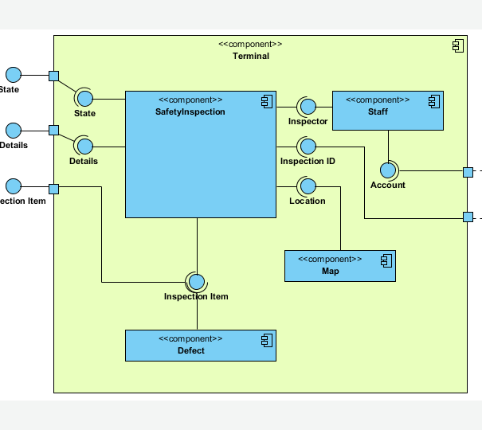
- Deployment diagram
- Deployment diagrams are used for visualizing deployment view of a system. This is generally used by the deployment team.
- Deployment diagram shows architecture of the system as deployment (distribution) of software artifacts to deployment targets.
- The deployment diagram is used for describing the hardware component where the software component is deployed.
- Deployment diagram is a structure diagram which shows architecture of the system as deployment (distribution) of software artifacts to deployment targets.
- Deployment target is usually represented by a node which is either hardware device or some software execution environment. Nodes could be connected through communication paths to create networked systems of arbitrary complexity.
- Deployment diagrams could describe architecture at specification level (also called type level) or at instance level (similar to class diagrams and object diagrams).
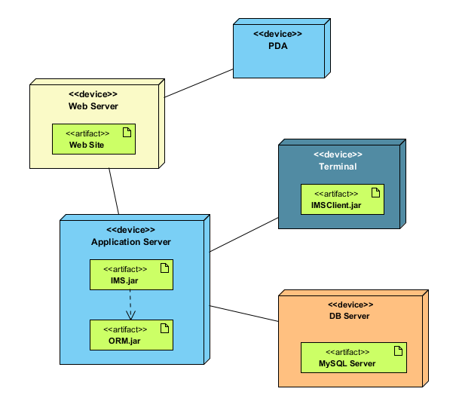
2.4 Behavioral Diagram.
Behavioral diagram basically capture the dynamic aspect of a system. Dynamic aspect can be further described as the changing parts of a system.
Behavioral diagrams depict the behavioral features of a system or business process. Behavior diagrams show the dynamic behavior of the objects in a system, which can be described as a series of changes to the system over time. Behavioral diagrams include the following diagram types:
- Use Case diagram
- Activity diagram
- Sequence diagram
- State machine diagram
- Collaboration diagram

Use Case diagram
- Use case diagram means what system will do? The use case is used to identify the primary elements and processes that form the system. Where, the primary element term as Actors and the process are called use case.
- Use case diagrams are a set of use case, actors and their relationships. They represent the use case view of a system.
- A use case represents a particular functionality of a system.
- So use case diagram is used to describe the relationships among the functionalities and their internal/external controllers. These controllers are known as actors.
- Use case diagrams are behavior diagrams used to describe a set of actions (use cases) that some system or systems (subject) should or can perform in collaboration with one or more external users of the system (actors) to provide some observable and valuable results to the actors or other stakeholders of the system(s).
- Use case diagrams capture Use Cases and relationships among Actors and the system; they describe the functional requirements of the system, the manner in which external operators interact at the system boundary, and the response of the system.
The different types of elements or notations are given bellow which is used for creating a use case
- Use case
- Actors
- Communication
- Include
- Extends
- System boundary

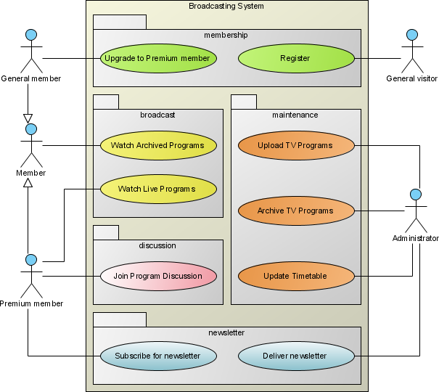

Activity diagram

Activity diagram describes the flow of control in a system. So it consists of activities and links. The flow can be sequential, concurrent or branched.
- Activities are nothing but the functions of a system. Numbers of activity diagrams are prepared to capture the entire flow in a system.
- Activity diagram is a special kind of state char diagram that shows the flow of the system.
- Activity diagrams are used to visualize the flow of controls in a system. This is prepared to have an idea of how the system will work executed.
- Activity diagram address the dynamic view of a system.
- Activity diagram is typically used for business process modeling. It gives details view of business logic.
- The Activity Diagram can help to describe the flow of control of the target system, such as the exploring complex business rules and operations, describing the use case also the business process.
- Activity diagrams are used to model the behaviors of a system, and the way in which these behaviors are related in an overall flow of the system.
- Activity diagram also consist of activity, actions, transaction, initial stage and final stage.
- The different elements of activity diagram are given bellow.
- Starting
- Action

- Decision
- Swim lanes
- Stop

- Responsibility of action/ control of the flow
- Transaction (forck)

- Joint transition

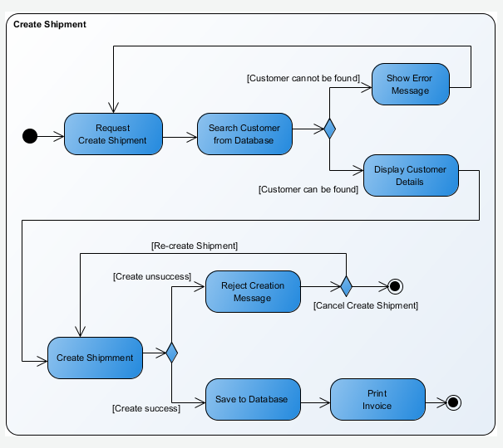
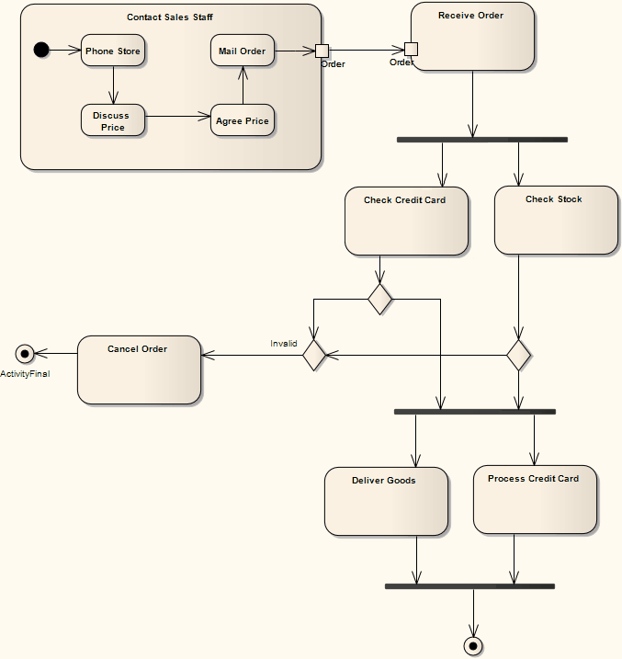

  - Sequence diagram

A sequence diagram is an interaction diagram. From the name it is clear that the diagram deals with some sequences, which are the sequence of messages flowing from one object to another.
- A sequence diagram can be used to explore the logic of a complex operation, function or procedure.
- A sequence diagram shows the interaction of a system with its actors to perform all or part of use case.
- Each actor as well as the system is represented by a vertical line called lifeline and each message by a horizontal arrow from the sender to receiver.

Sequence diagram is the most common kind of interaction diagrams, which focuses on the message interchange between lifelines (objects).

- The Sequence Diagram models the collaboration of objects based on a time sequence. It shows how the objects interact with others in a particular scenario of a use case.
- Sequence Diagrams are structured representations of behavior as a series of sequential steps over time. They are used to depict work flow, message passing and how elements in general cooperate over time to achieve a result.
The different notation/ elements of sequence diagram are given bellow.
- Forward message
- Message for return
- Lifeline - - - - - - - -

- Activation

- Object lifeline
|
|
|
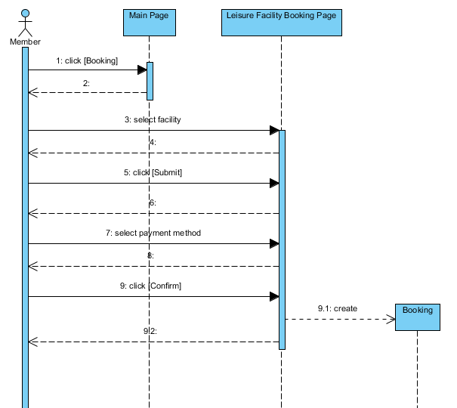

State machine diagram
- State machine diagram is used to represent the event driven state change of a system. It basically describes the state change of a class, interface etc.
- State machine diagram is used to visualize the reaction of a system by internal/external factors.
- A state diagram is a graph whose nodes are state a whose direct transaction between different states.
- State name must be unique within the scope of state diagram.
- State machine diagram is a behavior diagram which shows discrete behavior of a part of designed system through finite state transitions. State machine diagrams can also be used to express the usage protocol of part of a system.
- These two kinds of state machines are referred to as behavioral state machines and protocol state machines.
The different element of state diagram is given bellow.
- Initial state
- State
- Transition
- History state
H
- Final state
)

It also furnishes examples that illustrate how the graphic elements can be assembled into diagrams.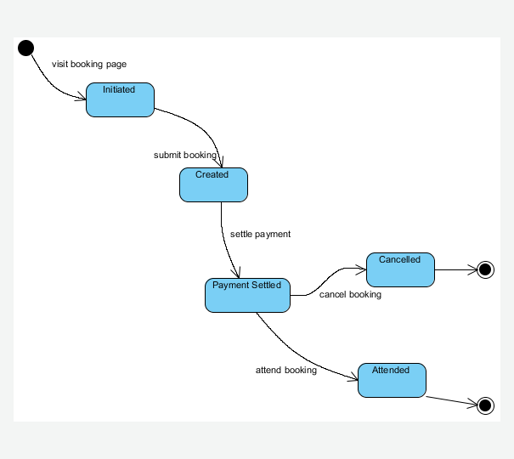

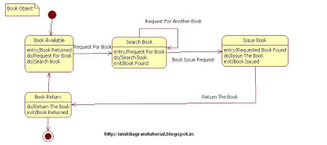
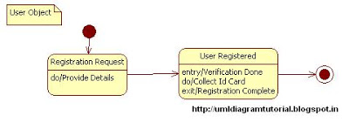
  - Collaboration diagrams
- Collaboration diagram is another form of interaction diagram. It represents the structural organization of a system and the messages sent/received. Structural organization consists of objects and links.
- The purpose of collaboration diagram is similar to sequence diagram. But the specific purpose of collaboration diagram is to visualize the organization of objects and their interaction.
- Collaboration use diagram shows objects in a system cooperating with each other to produce some behavior of the system.
- Collaboration describes a structure of collaborating elements (roles), each performing a specialized function, which collectively accomplishes some desired functionality (task). Details, such as the identity or precise class of the actual participating instances are suppressed.
- Collaboration is shown as a dashed ellipse icon containing the name of the collaboration. The internal structure of collaboration as comprised by roles and connectors may be shown in a compartment within the dashed ellipse icon.

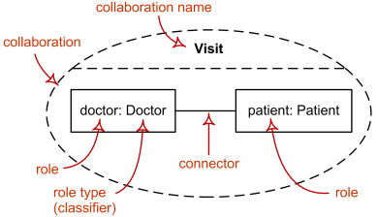

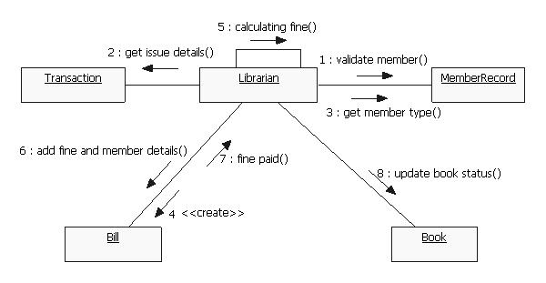
2.5 Modeling with Object.

A model is a simplification of reality.
A model may provide
  - blueprints of a system
  - Organization of the system
  - Dynamic of the system
A successful software organization is one that consistently deploys quality software that meets the needs of its users. An organization that can develop such software in a timely and predictable fashion, with an efficient and effective use of resources, both human and material, is one that has sustainable business.
Why we modeling
- Model is built to
  - Communicate the desired structure and behavior of the system
  - Visualize and control the system’s architecture
  - Better understand the system that being built
  - Manage risk
  - Expose opportunities for simplification and reuse
  - We build models so that we can see and better understand the system we are developing
Importance of Modeling
- Models help us
  - to visualize a system as it is or as we want it to be.
  - to specify the structure or behavior of a system.
  - in providing a template that guides us in constructing a system.
  - in providing documenting the decisions we have made.
- The choice of what models to create has a major influence on how a problem is approached and how a solution is shaped.
- Every model may be expressed at different levels of precision.
- The best models are connected to reality.
- No single model is sufficient. Every nontrivial system is best approached through a small set of nearly independent models.
Whenever a ModelRisk function takes a distribution as argument rather than a sampled value from it, this argument should be provided as a distribution object function.
Using distribution Objects has the great advantage that you can keep your distributional assumptions in once place in the model, making it easier to maintain and update (analogous to keep your constants in one place).

For each distribution, time series and copula in ModelRisk, there is a corresponding Object and a Fit Object function available for further use as an argument in other ModelRisk functions. Both types behave the same, but have their parameters specified in a different way: Object functions are directly specified by their parameters, and Fit Object functions are specified by the array of data they are fitted to. ModelRisk then determines parameter values that best fit the data.

It is important to know that the Distribution Object functions are in essence only "placeholders", i.e. creating them executes no algorithm. The algorithms are only executed when another Function calls the object as argument. The Distribution Fit Object functions are a different case: when inserting a fitted object, the fitted parameters are immediately calculated and contained in the object. Any further actions done on this fitted object will again only execute upon calling the object (e.g. calculating a probability with VoseProb)

There is a Distribution Object function for every distribution in Model Risk, including custom distributions (e.g. VoseCombined, VoseDeduct, VoseRiskEvent, VoseAggregateFFT). So all of these can be used further as argument in other Model Risk functions.
It makes logical sense to differ between a distribution as a whole, and a random value sampled from that distribution. It would be conceptually wrong and inconsistent to have the same function playing both roles.

To make your model as easy to maintain, review and update as possible we consider it good practice to store each used Distribution, Time Series or Copula (see below) object only once and in a separate spreadsheet cell, and refer to that cell from other Model Risk functions.The image below illustrates modeling with objects schematically.
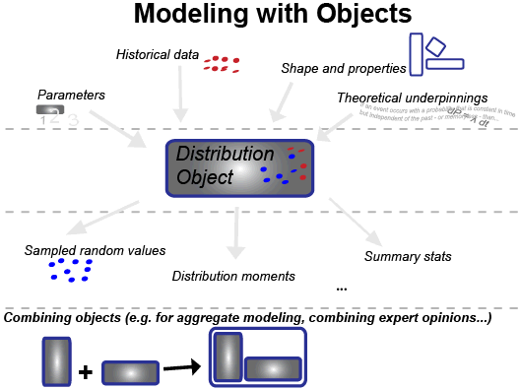
An example from insurance risk analysis

